Middle School Lunch Menu

March-April 2021

All Meals Must Include Salad Bar Selections
MONDAY | TUESDAY | WEDNESDAY | THURSDAY | FRIDAY
22  *BBQ Pulled Pork Sandwich  Lasagna/Breadstick  Turkey & Cheese Wrap  Green Peas | 23  Philly Cheesesteak  Chicken Alfredo Breadstick  Sub Sandwich  Green Beans | 24  Chili  Cinnamon Roll  Chicken Drumstick  Ham Sandwich  Corn | 25  Beef soft shell taco  Popcorn Chicken  Wow Butter & Jelly  Tater Tots | 26  Papa Murphy’s Pizza  Chili Dogs  Turkey Sandwich  Batter Bites
29  *Loaded Baked Potato Dinner Roll  Cheeseburger  Ham Sandwich  Baked beans | 30  Meatball Sub  French Toast/Omelet Syrup  Wowbutter & Jelly  Potato Smiles | 31  Sloppy Joes  Chicken N’ Biscuit  Ham & Cheese Wrap  Green Peas | 1  Boss-Hog Buffalo Sandwich  Pizza  Sub Sandwich  Crinkle-Cut Fries | 2  *No School*  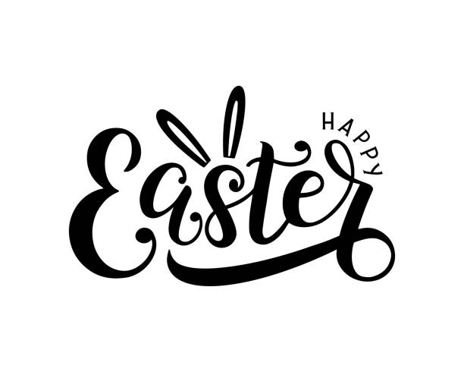
5  *No School* | 6  Tater Tot Hot Dish  Chicken Burger  Ham Sandwich  Green Beans | 7  Corn Dogs  Grilled Chicken Cordon Blue Sandwich  Wow Butter & Jelly  Curly Fries | 8  Beef Gravy & Mashed Dinner Roll  Fishwich  Turkey Sandwich  Mashed Potatoes | 9  *Chef Salad/Breadstick  Papa Murphy’s Pizza  Sub Sandwich  Corn
12  Pancakes & Eggs  Syrup  Pizza  Yogurt Parfaits  Turkey Sandwich  Potato Smiles | 13  Meatballs N’ Gravy/Roll  Chicken Nuggets/Roll  Ham & Cheese Wrap  Mashed Potatoes | 14  Teriyaki Chicken/Rice  Hot Ham N’ Cheese  Wow Butter & Jelly  Broccoli | 15  Spaghetti / Breadstick  Popcorn Chicken Breadstick  Turkey Sandwich  Corn | 16  Chicken Fajita  Papa Murphy’s Pizza  Submarine Sandwich  Baked Beans
Assorted fruits and vegetables are offered with all meal choices as well as their choice of milk (Skim, 1%, and Chocolate 1%)
All students eat free of charge for breakfast and lunch until further notice from the food service department.
Ala carte, super-size and extra milk are still charged to the student accounts.
Whole Grain (WG) Contains Pork* monitor all snacks for ingredients if you have an allergy

